Home learning 4
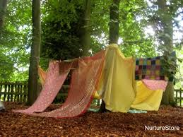
Activities to Support Physical Development
Gross Motor
- Den building – Using material, bed sheets, and pegs can you build a den?
What can you do in your den, have a Tea party? Teddy bears picnic? or Story time?
- Use jugs and pots to fill and empty in the bath.
- Encourage your child to try to put on their own shoes/ coat and challenge them to see what else they can you put on?
- Using brushes and water outside on a dry path encourage your child to make marks, to help them develop the first steps to writing skills.
- Catching and throwing balls - explore with big and small balls.
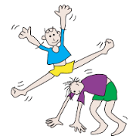
- You tube/ ask Alexa to play – sticky kids, there are some great actions songs you can do at home.
- Check out this you tube clip about winter animals https://www.youtube.com/watch?v=DXxzjmCFwTI
- choose winter animals such as Penguins, polar bears ask your child how do they think they move?

Tummy Time – Babies and young children
The activity – Sensory Play

Whenever you place a baby on their tummy, surround them with some interesting things., Toys, mirrors – anything that will make them want to turn around or flap their arms is great for their physical development. This will help strengthen arm, back, and neck muscles and can eventually lead to crawling. Consider putting the small items in sensory bags taped to the floor, to prevent any choking hazard. You can also place sensory items in bags such as foam, jelly, paint and secure the bag with tape allowing the baby to explore mess free.
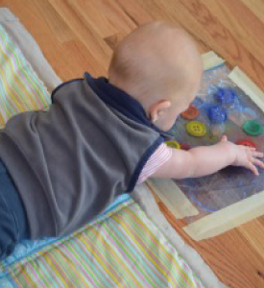
What you need –

Ziploc Bags
Tape
Various Items (buttons, beads, shells, pompoms, rice etc.)

Treasure Basket

A box filled with everyday items can absorb children’s attention for hours at a time. They explore, experiment, make choices on their own and get a chance to practice the pincer movements that are so key to their physical development.
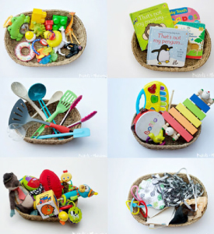

What you need –

Fruits & Veggies
Wooden and Plastic Objects
Soft Toys
Kitchen Utensils
Balls

Fine Motor
- Threading pasta onto string to create jewellery. You could colour the pasta with food colouring and leave it to dry on paper towel over night.
- Using string can you make a washing line, then using socks and pegs encourage your child to peg the socks on the washing line? How many socks can they count? Which ones are the same? Can they make a pattern?
- Pipe cleaners and cheerios’ make a good threading activity when you have threaded the hoops twist the end of the pipe cleaners and hang on a tree for the birds.
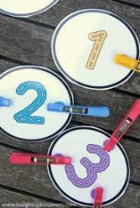
- Using paper or cardboard cut-out circles and give each circle a number, write the numbers on 1, 2, 3, provide pegs and encourage the child to place the right number of pegs on each circle.

Activities to support Literacy/ Communication and Language.

Try cooking and baking with your child – where talk is used to anticipate or initiate what children will be doing, e.g. We need some eggs, let’s see if we can find some in here?
Introduce words to describe the texture of the ingredients you are using. Observe and talk about how the mixture changes when the ingredients are mixed together. Reinforce words such as more, less, try counting the eggs or the spoons of flour.

Follow the link to the story the very hungry caterpillar.

https://www.youtube.com/watch?v=75NQK-Sm1YY

Try exploring some of these questions around the story with your children.

What is your favourite food?

The moon is white the sun is ………...?

Do you remember what the caterpillar made to hide in?

Try curling into a ball and slowly pushing you way out and become a butterfly.

Here are some fun activities following the story.

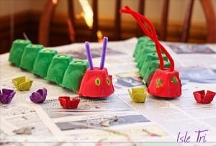

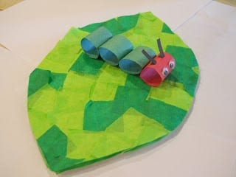

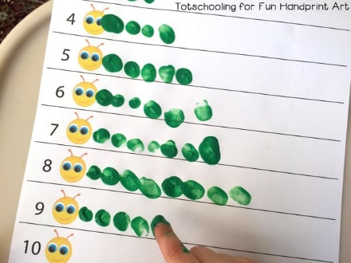

Activities to support Personal, Social, and Emotional Development.

- Using a mirror ask your child to talk about their body parts/ talk about how they are feeling, teddies are a great way to explore our feelings.
- Using pens and paper draw simple emotion faces and talk about how each face feels.
- Take pictures of an activity or special moment and enjoy sharing the pictures with your child talking about the activity.
- Ball games that require two people to participate can promote co-operation between two children/ child and adult.

Turtle Time

When you and your child go to the park, woods, garden etc... look around like a turtle in a slow, exaggerated fashion. Take turns sharing details about what you see: e.g. “All the swings are taken.”

You don’t have to pretend to be turtles you can use pretend binoculars.

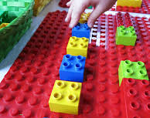
Activities to support early maths Development.
- Creating patterns, you can use objects from around the house, coloured blocks, leaves, twigs, and natural resources.
- Adult – Patterns- create a pattern and make a mistake e.g., red, yellow, red, yellow, blue? Ask the children if they can see what is wrong with the pattern and see if they can spot the mistake.
Example: red, yellow, red, yellow
Leaf, stick, leaf, stick
- Shape hunt- Can you go on a shape hunt around your house ask your child how many circles can you see? How many triangles can you spot?
- Using boxes can you talk about size, ask your child what boxes are big and what boxes are small? Can they order the boxes from big to small?
- Play games - try using a teddy or favourite toy, talk about positioning, i.e. Can you place the teddy behind the box, in the box, Infront of the box?
- Cut out old birthday or Christmas cards to create simple jigsaws.

Learning Outdoors
Personal, social, and emotional development ideas:
- Try low-level experiences for babies and young children, like using old tyres as a sturdy base for investigations – they could be a holder for a washing up bowl for water play or a planter for herbs to investigate.
- Wind chimes and windsocks, old CDs, and other objects suspended from a tree branch make interesting things for babies and young children to watch and adults to key into cues.
- Construction with crates, planks, large blocks are great for physical development and problem-solving.

Communication and language ideas:
- Try reading stories outside, you could build a den and read some favourite books inside.
- Songs and rhymes work just as well inside as outside.
- Listen to the sounds – birds, bees, aeroplanes, cars, and emergency service sirens- and talk about what is making them. Conversations about the weather are a fantastic opportunity to extend language, talking about the wind ‘blowing’, ‘swishing’ and so on.
- Make puppets and use them, thinking about how you can pretend play outside like a garden centre or car wash, for example.
- Sometimes providing a narrative can help support learning, talking about what children are doing “jumping up and down” or “splish splash” (as they jump in puddles).
Physical development ideas:
- Consider how babies can safely explore outdoors. For example, how to facilitate tummy time, chances to learn to crawl, creep and walk.
- Make instruments and explore movement, giving children free rein to move and dance. Dance with ribbons and scarves to encourage gross motor skills, crossing the midline and bi-lateral movements.
- Help children to help build an assault course outside.
- Sweeping brushes and other tools can help develop more physical skills. Large scale mark-making can be done with chalks or water and large brushes on the floor or a large piece of paper.

