Home Learning 3
Early Years Home Learning

Ideas to Support Phase 1 Phonics-
- Explore with children the sounds different animals make, including imaginary ones such as dragons. You can use animal toys, books, pictures or role play acting out the animals.

- Explore objects around the house and what sounds they make, what objects make a similar sound? Are they making loud or quiet sounds?

- Can you make up simple rhythms, try clapping, stamping, tapping?

- Explore sensory play by making bowls of foamy water, pasta, foam- introduce new words such as fluffy, crunchy, to describe the texture.

- In your garden or in an outdoor space try pausing and listening to what sounds you can hear?

- When doing the washing can you match the right pairs of socks?

- Encourage children’s word play by inventing new rhymes such as hickory dickory dable the mouse ran up the table.

- Enjoy sharing books with your child, talk about the pictures and what they think will happen next.

- Use a toy or a game you already have, give your child a limited choice and follow his/her lead. Listen to your child and talk about things which interest them.

- Use puzzles – make up the puzzle and then take turns to ask each other to find 10 things in the picture.

- Shopping- collect empty cartons and boxes. Use these to set up a pretend shop. Ask your child to go to the shop and buy one or 2 things.

Magic bag- Collect a bag of everyday objects
- Hairbrush, cup, spoon, plate, shoe, book.

Give your child a matching object as he/she tries to do things in real situations. He/ she will then copy you and learn how to use it. For example

- Give your child a second spoon whilst feeding.
- - give your child another shoe whilst dressing
- - give your child a spare sponge whilst washing.

Playdough Recipe (Adults to make)
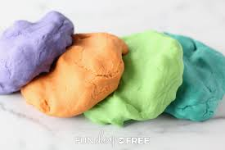
1 cup of warm water
1 cup of flour
1 tablespoon of cream of tartar
½ cup of salt
1 tablespoon of oil
(1 cup = 8fl oz when using a measuring jug)

Put all the ingredients in a saucepan and stand over a gentle heat.
As the water heats everything forms a thick paste. It is essential to keep stirring.
Add food colouring to colour the dough
Add glitter for special effects
Add peppermint or almond essence to intrigue the sense of smell.

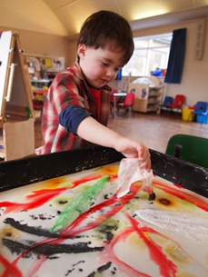
Gloop recipe

You will need:

A large packet of cornflour
Water to mix

Put the cornflour in a tray or large bowl ad the water slowly and mix together to form a paste.
Add food colouring and try adding two colours at different ends of the tray for your child to mix.
Add in household objects such as big and small spoons, spatulas to explore in the gloup.
RAINBOW GLOOP!
The secret to this one is baby wipes!
Mix your gloop (or goop) as usual in a builders tray. Then paint it with food colouring. The best way to do this is to dip the corner of a baby wipe into the food colouring and then hold the clean bit.
That way you can dip and drag your wipe without getting stained fingers.
Once you have made your picture then play in it.
Physical Play
Physical play helps children to learn how to control his/ her body, gain independence, explore the objects and situations around him. See below for some activity ideas to support with physical play.

Activities
Under 2 years of age
- Lying on his/her back with a play centre type equipment to look at and grasp
- Lying on his/her front and strengthening his/her head and neck as he looks up and reaches out.
- Tickling games
- Rolling games
- peek a boo games

Over 2 years

- Climbing on frames and swinging on swings
- Managing obstacle courses
- Chasing games
- Catching beanbags and large, soft balls
- Peddling bikes
- Musical bumps and statues.
Pretend play helps your child:
- Experiment by being different characters and exploring how people feel and what they say.
- learn how to understand other people and so improve their ability to socialise.
- Develop the thinking and reasoning skills he/ she will need for the rest of his/ her life.
Activities Include-
- Dressing up
- Playing pretend games such as vets, make a shop or café
- Using puppets
- Teddy bears picnic.

Hungry Caterpillar Hopscotch
What you need:
Playground chalk
Stone or counter
Copy of The Very Hungry Caterpillar (optional)
What to do:
Using chalk draw the head and body of a caterpillar with the children.
Make sure that the body of the caterpillar is very ‘wiggly’ and not just in a straight line!
Number each of the circles that make the caterpillar’s body.
Ask the children to throw their counter onto the caterpillar’s body and hop to where it lands.
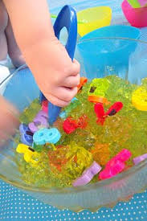
Early Years Maths Activity: – Learning Numbers with Jelly
What you need –
Jelly
Bowls
Plastic Numbers
Tongs
First, spread out some plastic numbers in jelly layers. When it’s all set, give out some tongs to children and show them how to pick up the numbers from the wiggly substance

LEGO Patterns
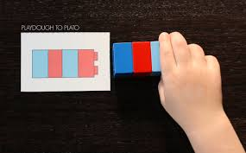
The early years maths activity: – DIY Lego Pattern Cards
What you need –
Paper Cards
Coloured Pencils
LEGO Blocks
Prepare some cards with colourful blocks on them and let kids discover colour patterns and reproduce them with LEGO blocks.

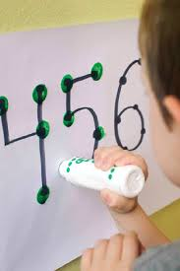
Do-a-Dots
Number Dots and Easy Touch And Count.
What you need –
Parchment Paper
Sharpie Marker
Dot marker
Tape some parchment paper to the wall / table and write several numbers, each decorated with as many dots as the number. Now, kids can touch each dot with a dot marker and see the number and the quantity all together! You can also put the paper on the floor but holding a marker up and out makes this not only an activity for early years maths but also a good way to strengthen those little arm muscles.

Ice Art
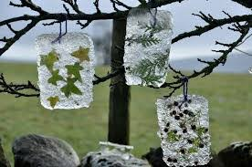
These pieces of art are really easy to make.
You will need:
A shallow container
Some water
Natural objects and some wool or string.

Put a couple of centimeters of water in the bottom of your container. Add your natural materials. if you want to hang them up then put a loop of wool or string into the water before you leave them outside overnight to freeze.
Once they have set then you turn them out of the container and hang outside.
You might want to provide magnifying glasses for the children to use when looking closely at their frozen art.

These are a really easy and very effective make.
You will need:
Some party balloons
Water
Food colouring.

Fill the balloon with water (as big as you dare) then holding the balloon by the neck add food colouring.
The easiest way is to add the food colouring is by dipping a cotton bud into the colour and then poking that down the neck of the balloon.
Part of the joy of this activity is that you never know quite what shade of colour your balloon marble is going to be.
Once the ice has set inside the balloon. Snip the tied end off and peel back the rest. They produce some amazing patterns as they melt.
Some useful online learning

https://hungrylittleminds.campaign.gov.uk/

